Predicting Diabetes Risk Using Machine Learning
A Comparative Analysis of Nine Supervised Classifiers on the CDC BRFSS 2015 Dataset
Yaswanth Moapda | Srujith Borra | Uday Ankam
CSP 571 ,Machine Learning | Spring 2026
Abstract
Diabetes mellitus affects over 37 million Americans, with approximately 25% remaining undiagnosed until complications develop. This study evaluates whether machine learning models trained exclusively on self-reported survey data can achieve clinically meaningful predictive accuracy. We train and compare nine supervised classifiers on the CDC BRFSS 2015 dataset (67,920 class-balanced records, 21 features). Gradient Boosted Machines and XGBoost achieve the highest discrimination (AUC ≈ 0.83), but Logistic Regression follows closely (AUC = 0.820), suggesting the feature-outcome relationship is predominantly linear. The findings support the feasibility of survey-based screening tools and demonstrate that interpretable models retain practical utility relative to complex alternatives.

1. Introduction
Type 2 diabetes mellitus is among the most prevalent chronic conditions in the United States, affecting an estimated 37 million adults, with an additional 96 million classified as pre-diabetic [1]. A critical public-health challenge is that approximately 25% of affected individuals remain undiagnosed until complications such as neuropathy, nephropathy, or cardiovascular disease have already manifested. Early identification of at-risk individuals is therefore of substantial clinical value, yet conventional diagnostic pathways require laboratory glucose measurements that depend on clinical access and infrastructure.
Machine learning offers a complementary approach: leveraging behavioral and demographic survey data ,collected at minimal cost ,to identify high-risk individuals for targeted clinical follow-up. The Behavioral Risk Factor Surveillance System (BRFSS) [2], administered annually by the CDC, provides large-scale survey data ideally suited to this task. This study addresses three research questions: (i) whether survey-based features alone achieve clinically meaningful predictive accuracy; (ii) which of nine candidate classifiers spanning different inductive biases yields the strongest discrimination; and (iii) the extent to which non-linear modeling improves over a linear baseline, and what this implies about the structure of the underlying relationship.

2. Dataset and Preprocessing
The analysis uses diabetes_binary_5050split_health_indicators_BRFSS2015.csv from the UCI Machine Learning Repository [3] (https://archive.ics.uci.edu/dataset/891/cdc+diabetes+health+indicators), a class-balanced variant of the BRFSS 2015 survey containing 70,692 records, 21 predictors, and a binary diabetes outcome. The predictor set comprises 14 binary indicators (HighBP, HighChol, CholCheck, Smoker, Stroke, HeartDisease, PhysActivity, Fruits, Veggies, HvyAlcoholConsump, AnyHealthcare, NoDocbcCost, DiffWalk, Sex) and 7 continuous variables (BMI, GenHlth, MentHlth, PhysHlth, Age, Education, Income).
Each preprocessing decision was made deliberately to ensure unbiased and algorithm-appropriate inputs. (i) Duplicate removal eliminated 1,635 redundant records to prevent data leakage between train and test partitions [4]. (ii) Class balancing through majority-class downsampling produced a 50/50 distribution (67,920 rows total), eliminating the majority-class bias that systematically distorts threshold-sensitive classifiers like Logistic Regression and SVM. (iii) Binary predictors were encoded as factors to ensure tree-based models treat them categorically rather than ordinally. (iv) Continuous predictors were z-score standardized ,required for distance- and gradient-based algorithms whose loss surfaces are sensitive to feature scale. Tree-based methods are scale-invariant, making this preprocessing step conservative and harmless. (v) A stratified 70/30 split produced training (47,544) and test (20,376) partitions with preserved class balance, enabling reliable estimation of test-set metrics.

3. Exploratory Data Analysis
EDA was conducted before modelling to identify predictive signal, assess distributional assumptions, and inform model selection. Findings from this phase directly motivated the inductive bias choices in Section 4.
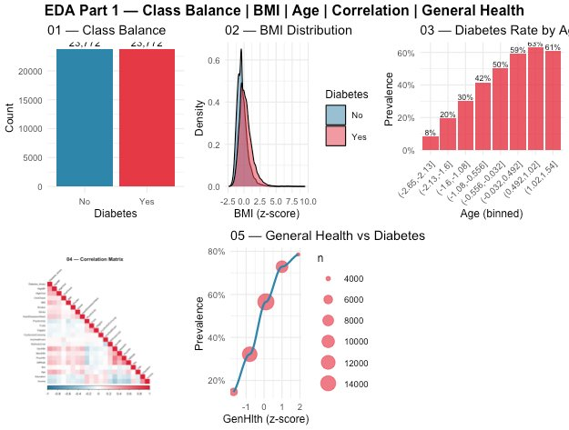
Figure 1 ,EDA Part 1: Class balance, BMI distribution, age-stratified prevalence, correlation heatmap, general health vs. prevalence.
Plot 01 confirms the 50/50 balance achieved through preprocessing (23,772 per class). Plot 02 reveals a clear rightward shift in the BMI distribution for diabetic individuals, consistent with the established adiposity-diabetes pathway [5]. Plot 03 demonstrates that diabetes prevalence increases near-monotonically with age ,from 8% in the youngest cohort to 61% in the oldest ,suggesting age behaves as a near-linear predictor and providing the first indication that simpler linear classifiers may achieve competitive performance. The correlation heatmap (Plot 04) shows no inter-predictor correlation exceeding |r| ≈ 0.5, indicating multicollinearity is not a concern; this finding is later confirmed empirically by the Lasso analysis. Plot 05 reveals a near-perfect monotonic relationship between self-rated general health and diabetes prevalence, establishing GenHlth as the strongest single predictor.
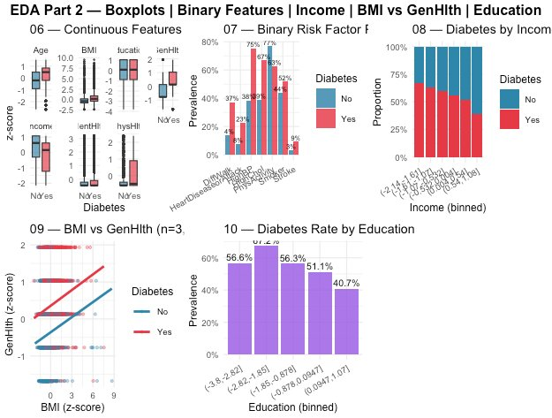
Figure 2 ,EDA Part 2: Continuous feature boxplots, binary feature prevalence, income gradient, BMI vs. GenHlth scatter, education gradient.
Plot 06 confirms group differences across all continuous features, justifying retention of the full predictor set rather than aggressive feature selection. Plot 07 shows HighBP exhibits the largest binary-feature gap (67% vs. 37%) between groups, while PhysActivity (52% vs. 77%) reveals a behavioral pathway partially independent of physiological markers. Plots 08 and 10 reveal consistent socioeconomic gradients: diabetes prevalence decreases with both income and education ,patterns reflecting established health disparity mechanisms [6] and confirming these features carry genuine signal rather than acting as noise variables.

4. Model Selection and Training
Nine models were selected to span hypothesis classes directly motivated by the EDA. The near-linear age and general health trends suggested a linear classifier would be competitive ,motivating Logistic Regression as the baseline and Lasso as its regularized variant [7] to test whether any features are redundant. The distributional overlap and multi-feature interactions visible in EDA Plots 06–07 motivated tree-based ensembles: Decision Tree for interpretability, Random Forest [8] for variance reduction through bagging, and Gradient Boosted Machines [9] and XGBoost [10] for sequential error correction better suited to moderate class overlap. SVM [11] was included as a margin-based comparison, k-NN [12] as a distance-based local classifier, and a Neural Network as a non-parametric universal approximator.
Model | Training Data | Specification & Justification
Logistic Regression | Full (47,544) | Binomial GLM with all 21 features. Selected as interpretable linear baseline; EDA linear trends suggested it would be competitive.
Lasso (glmnet) | Full (47,544) | alpha=1, lambda by 5-fold CV (λ≈8e-4). Tests redundancy; near-zero λ confirms all features are useful.
Decision Tree | Full (47,544) | rpart, cp=0.001, maxdepth=6. Provides interpretable decision rules to complement ensemble methods.
Random Forest | Full (47,544) | 300 trees, mtry=4, importance tracked. Captures non-linear interactions; provides feature importance.
GBM | Full (47,544) | 500 trees, depth=3, shrinkage=0.05. Sequential boosting suited to moderate class overlap observed in EDA.
XGBoost | Full (47,544) | 400 rounds, eta=0.05, depth=4, subsample=0.8. Regularized boosting tested against potential overfitting.
SVM | 10% (4,756) | Linear kernel, cost=1, probability output. Margin-based comparison; sub-sampled due to O(n²) memory.
Neural Network | 10% (4,756) | 1 hidden layer, 8 units, decay=0.01, 200 iters. Universal approximator baseline; sub-sampled for compute.
k-Nearest Neighbors | 10% (4,756) | k=21 (≈√n). Distance-based local classifier; sub-sampled due to O(n_train × n_test) inference cost.

SVM, Neural Network, and k-NN were trained on a 10% stratified subsample (4,756 rows) due to the O(n²) memory cost of the SVM kernel matrix and the O(n_train × n_test) inference cost of k-NN. This is an acknowledged limitation: their reported metrics represent lower bounds on full-data performance and should not be directly compared to the six full-data models.

5. Results and Evaluation
All nine models were evaluated on the 20,376-row held-out test set at a classification threshold of 0.5. Six metrics are reported: Accuracy, Sensitivity (recall of the positive class), Specificity (recall of the negative class), Precision, F1-score, and AUC. In a medical screening context, Sensitivity and AUC are prioritized because the asymmetric cost of false negatives ,a missed diabetic case ,substantially exceeds the cost of false positives.
Model | Accuracy | Sensitivity | Specificity | Precision | F1 | AUC
GBM | 0.7486 | 0.7892 | 0.7081 | 0.7300 | 0.7584 | 0.8266
XGBoost | 0.7482 | 0.7861 | 0.7104 | 0.7311 | 0.7576 | 0.8255
Logistic | 0.7456 | 0.7673 | 0.7239 | 0.7354 | 0.7510 | 0.8197
Lasso | 0.7454 | 0.7675 | 0.7233 | 0.7350 | 0.7509 | 0.8197
SVM | 0.7442 | 0.7629 | 0.7256 | 0.7354 | 0.7489 | 0.8183
RandomForest | 0.7411 | 0.7847 | 0.6974 | 0.7217 | 0.7519 | 0.8135
NeuralNet | 0.7266 | 0.7487 | 0.7046 | 0.7171 | 0.7325 | 0.7983
DecisionTree | 0.7180 | 0.7345 | 0.7015 | 0.7110 | 0.7226 | 0.7895
kNN | 0.6892 | 0.6914 | 0.6870 | 0.6884 | 0.6899 | 0.7548

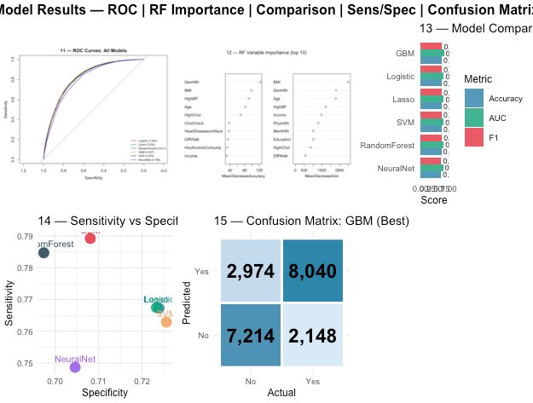
Figure 3 ,Model results: ROC curves for all nine models, RF variable importance, metric comparison, sensitivity vs. specificity scatter, GBM confusion matrix.

5.1 Overall Performance
GBM and XGBoost achieve the highest discrimination (AUC = 0.827 and 0.826 respectively), consistent with theoretical expectations that sequential boosting outperforms bagging on moderately overlapping class distributions. The near-equivalent performance of these two boosting variants further suggests that XGBoost's additional regularization provides only marginal benefit on this dataset ,likely because the dataset is already well-conditioned after preprocessing. The most analytically significant finding, however, is that Logistic Regression closely follows (AUC = 0.820), with an AUC gap of only 0.007 from the best model. This near-equivalence indicates that the feature-outcome relationship is predominantly linear, and that non-linear ensemble methods provide marginal but not transformative improvement. It directly implies that an interpretable Logistic Regression model could be deployed with minimal predictive sacrifice relative to GBM, while preserving clinical interpretability of coefficients.
The Lasso model's cross-validated regularization parameter settled at λ ≈ 0.00082 ,effectively applying no shrinkage and retaining all 21 features. This empirically confirms the EDA hypothesis that all predictors carry genuine signal and that multicollinearity is insufficient to cause estimation instability. Three models underperformed the leading group: k-NN (AUC = 0.755) suffers from the curse of dimensionality, as 21 features create a sparse feature space where distance-based classification degrades; Decision Tree (AUC = 0.790) captures only axis-aligned splits and cannot leverage the smooth gradients in continuous features that ensemble methods aggregate over; and Neural Network (AUC = 0.798) was constrained to a 4,756-row subsample, where shallow networks underperform their full-data potential.

5.2 Variable Importance and EDA Validation
The Random Forest variable importance plot (Plot 12) ranks GenHlth and BMI as the top predictors by both Mean Decrease Accuracy and Mean Decrease Gini ,precisely the features showing the most pronounced group differences in the EDA correlation and density analyses. This internal consistency between exploratory findings and model-learned importance provides evidence that the models capture genuine population-level risk patterns rather than overfitting to spurious correlations. Age, HighBP, and Income follow in importance, again mirroring EDA Plots 03, 04, and 08. This congruence also validates the decision not to apply aggressive feature selection prior to modelling.

5.3 Clinical Decision Analysis
Because false negatives carry higher clinical cost than false positives in a screening context, Sensitivity is the operationally critical metric. GBM and Random Forest achieve the highest Sensitivity (78.9% and 78.5% respectively), making them the preferred deployment models. The GBM confusion matrix (Plot 15) shows 8,040 true positives, 7,214 true negatives, 2,974 false positives, and 2,148 false negatives ,the lowest false negative count of all nine models. At the default threshold of 0.5, approximately 21% of diabetic individuals are missed; lowering the threshold would reduce this rate at the cost of additional false positives, a trade-off requiring calibration against deployment-specific cost structures.

6. Conclusions and Future Work
This study demonstrates that diabetes risk can be predicted with AUC ≈ 0.83 and Sensitivity ≈ 79% using only self-reported survey data ,without any laboratory measurements. Among nine candidate classifiers, GBM and XGBoost achieve the strongest discrimination, but Logistic Regression's near-equivalent performance reveals that the feature-outcome relationship is predominantly linear; non-linear ensemble methods add marginal but not transformative value. GBM remains the recommended deployment model due to its highest sensitivity and lowest false negative count, but Logistic Regression is a defensible alternative where interpretability is required. The top predictors ,General Health, BMI, Age, HighBP, and Income ,align with established epidemiological understanding of Type 2 diabetes risk [5, 6]. Three limitations warrant acknowledgment: (i) SVM, Neural Network, and k-NN results are subsample lower bounds; (ii) the 50/50 training distribution requires probability recalibration via Platt scaling or isotonic regression before deployment under realistic ≈14% population prevalence; (iii) self-report introduces measurement error and recall bias. Future work should address these through full-data training for all models, hyperparameter optimization, ensemble stacking, threshold optimization for clinical sensitivity targets, and validation on more recent BRFSS cycles.

References
[1] Centers for Disease Control and Prevention. National Diabetes Statistics Report. Atlanta, GA: U.S. Department of Health and Human Services, 2022.
[2] CDC. Behavioral Risk Factor Surveillance System: 2015 Survey Data and Documentation, 2016.
[3] UCI Machine Learning Repository. CDC Diabetes Health Indicators Dataset, 2023. https://archive.ics.uci.edu/dataset/891.
[4] Kaufman, S., Rosset, S., & Perlich, C. Leakage in data mining: Formulation, detection, and avoidance. ACM TKDD, 2012.
[5] American Diabetes Association. Standards of Medical Care in Diabetes. Diabetes Care, 46(S1), 2023.
[6] Hill-Briggs, F., et al. Social determinants of health and diabetes. Diabetes Care, 44(1):258–279, 2021.
[7] Tibshirani, R. Regression shrinkage and selection via the lasso. JRSS-B, 58(1):267–288, 1996.
[8] Breiman, L. Random forests. Machine Learning, 45(1):5–32, 2001.
[9] Friedman, J. H. Greedy function approximation: A gradient boosting machine. Annals of Statistics, 29(5):1189–1232, 2001.
[10] Chen, T., & Guestrin, C. XGBoost: A scalable tree boosting system. Proceedings of KDD '16, 785–794, 2016.
[11] Cortes, C., & Vapnik, V. Support-vector networks. Machine Learning, 20(3):273–297, 1995.
[12] Cover, T., & Hart, P. Nearest neighbor pattern classification. IEEE Trans. Information Theory, 13(1):21–27, 1967.

GITHUB REPO LINK: https://github.com/yaswanth073/Predicting-Diabetes-Risk-Using-Machine-Learning
Data Source: https://archive.ics.uci.edu/dataset/891/cdc+diabetes+health+indicators
Source Code: You can find the code from the github repository

